**Mini Project**

Project: **IoT based weather monitoring**

**System**

Name : **Apoorva Srivastava**

Course: Diploma

Branch: Electronics

Submitted to : Mohd. Ahmer sir

Remarks:-

**#Environment Monitoring System** :-

An IOT application is used to monitor the environment that helps monitor the environmental condition of any local area or a surrounding area, and with the help of the internet everyone can view the condition. This application is more efficient, quicker in offering conditions for the environment . It enables people or government to take remedial action if the environmental condition becomes abnormal. Environmental condition monitoring system offers a technique for verifying the condition and changes occurs over the surrounding. In this system we use Arduino, sound sensor, gas sensor, temperature sensor, moisture sensor, pressure sensor, IOT module. The humidity and temperature sensor will track climate change and provide information. It is helpful for agriculture . To monitor pollution over the atmosphere, the gas and sound sensor are used. Currently, pollution from air and noise makes the environment more susceptible. Using this module, we can identify the polluted area and expressly create people’s consciousness for living in the pollution. Changes in the climate system cannot be accurately defined and sometimes accidentally defined, but with the help of an IOT module we can characterize more approximate changes in an environment and update them in the cloud. This system uses many modules as follows.

**#Introduction to IOT:-**

**IoT is a network in which all physical objects are connected to the internet** through network devices or routers and exchange data. IoT allows objects to be controlled remotely across existing network infrastructure.

Or

The Internet of Things (IoT) is a system of interrelated computing devices, mechanical and digital machines, objects, animals or people that are provided with unique identifiers and the ability to transfer data over a network without requiring human-to-human or human-to-computer interaction.”

In other words,

The Internet of Things, called the IoT for short, is a new interconnection of technology heralded as the next industrial revolution—implying radical change, disruption, and an entirely new paradigm for the planet. Specifically, the Internet of Things is an extension of the existing connections between people and computers to include digitally-connected “things.”

**#Advantages of IOT:-**

Internet of things facilitates the several advantages in day-to-day life in the business sector. Some of its benefits are given below

1. **Efficient resource utilization:**

If we know the functionality and the way that how each device work we definitely increase the efficient resource utilization as well as monitor natural resources.

1. **Minimize human effort:**

 As the devices of IoT interact and communicate with each other and do lot of task for us, then they minimize the human effort.

1. **Save time:**

 As it reduces the human effort then it definitely saves out time. Time is the primary factor which can save through IoT platform.

1. **Improve security:**

 Now, if we have a system that all these things are interconnected then we can make the system more secure and efficient.

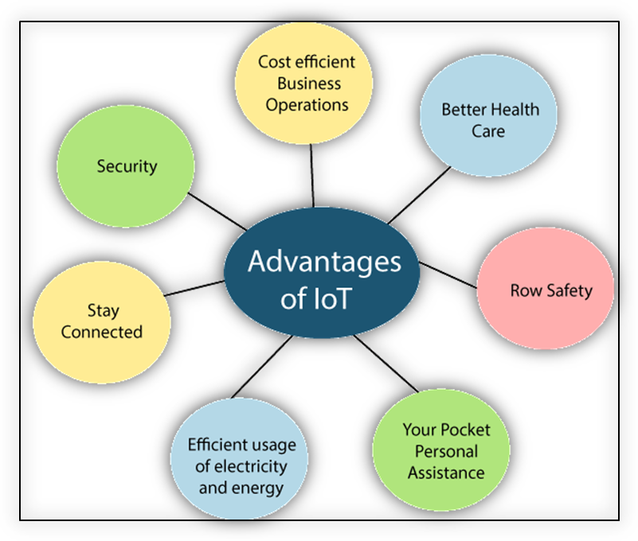

**#Disadvantages of IOT:-**

1. **Security:**

As the IoT systems are interconnected and communicate over networks. The system offers little control despite any security measures, and it can be lead the various kinds of network attacks.

1. **Privacy:**

 Even without the active participation on the user, the IoT system provides substantial personal data in maximum detail.

1. **Complexity:**

The designing, developing, and maintaining and enabling the large technology to IoT system is quite complicated.

**#Applications of IOT:-**

**(1) Wearables:-**

Virtual glasses, fitness bands to monitor for example calorie expenditure and heart beats, or GPS tracking belts, are just some examples of wearable devices that we have been using for some time now.

These are small and energy efficient devices, which are equipped with sensors, with the necessary hardware for measurements and readings, and with software to collect and organize data and information about users.

### ****(2) Health:-****

### **The Internet of Things helps to improve the care for patients and the prevention of lethal events in high-risk patients.**

### ****(4)Traffic monitoring:-****

### **When we use our mobile phones as sensors, which collect and share data from our vehicles through applications such as Waze or Google Maps, we are using the Internet of Things to inform us and at the same time contribute to traffic monitoring.**

### ****(5)Fleet management :-****

**The application of the Internet of Things to fleet management assists with geolocation (and with it the monitoring of routes and identification of the most efficient routes), performance analysis, telemetry control and fuel savings , the reduction of polluting emissions to the environment and can even provide valuable information to improve the driving of vehicles.**

### ****(5) Agriculture:-****

**Through the implementation of IoT sensors, a significant amount of data can be obtained on the state and stages of the soil.**Information such as soil moisture, level of acidity, the presence of certain nutrients, temperature and many other chemical characteristics, helps farmers control irrigation, make water use more efficient, specify the best times to start sowing, and even discover the presence of diseases in plants and soil.

### ****(6) Hospitality:-****

With the use of electronic keys, the check-outprocess is automated, disabling the operation of doors, offering information about the rooms immediately available, and even assigning housekeeping tasks to maintenance personnel.

### ****(7)Smart grid and energy saving:-****

It also allows offering valuable information to the end user about their consumption patterns and about the best ways to reduce or adjust their energy expenditure.

### ****(8) Water supply:-****

A sensor, either incorporated or adjusted externally to water meters, connected to the Internet and accompanied by the necessary software , helps to collect, process and analyze data, which allows understanding the behavior of consumers, detecting faults in the supply service, report results and offer courses of action to the company that provides the service.

**#Introduction to arduino:-**

Arduino is a microcontroller based prototyping board which can be used in developing digital devices that can read inputs like finger on a button, touch on a screen, light on a sensor etc. and turning it in to output like switching on an LED, rotating a motor, playing songs through a speaker etc

.

The Arduino board can be programmed to do anything by simply programming the microcontroller on board using a set of instructions for which, the Arduino board consists of a USB plug to communicate with your computer and a bunch of connection sockets that can be wired to external devices like motors, LEDs etc.

The aim of Arduino is to introduce the world of electronics to people who have small to no experience in electronics like hobbyists, designers, artists etc.

**#Introduction to Arduino IDE:-**

(1)[Arduino IDE](https://www.theengineeringprojects.com/2018/10/introduction-to-arduino-ide.html) is an open source software that is mainly used for writing and compiling the code into the Arduino Module.

(2)It is an official Arduino software, making code compilation too easy that even a common person with no prior technical knowledge can get their feet wet with the learning process.

(3)It is easily available for operating systems like MAC, Windows, Linux and runs on the Java Platform that comes with inbuilt functions and commands that play a vital role for debugging, editing and compiling the code in the environment.

(3)A range of Arduino modules available including Arduino Uno, Arduino Mega, Arduino Leonardo, [Arduino Micro](https://www.theengineeringprojects.com/2018/09/introduction-to-arduino-micro.html) and many more.

(4)Each of them contains a a [microcontroller](https://www.theengineeringprojects.com/2018/03/introduction-to-microcontrollers.html) on the board that is actually programmed and accepts the information in the form of code.

(5)The main code, also known as a sketch, created on the IDE platform will ultimately generate a Hex File which is then transferred and uploaded in the controller on the board.

(6)The IDE environment mainly contains two basic parts: Editor and Compiler where former is used for writing the required code and later is used for compiling and uploading the code into the given Arduino Module.

(7)This environment supports both C and C++ languages.

**#Sensors:-**

**Sensors** are sophisticated devices that are frequently used to detect and respond to electrical or optical signals. A **Sensor** converts the physical parameter (for example:  temperature, blood pressure, humidity, speed, etc.) into a signal which can be measured electrically.

**#DHT11 Sensors - Concepts & Working:-**

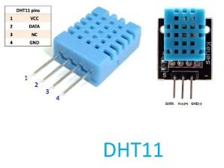

The DHT11 is a basic, ultra low-cost digital temperature and humidity sensor. It uses a capacitive humidity sensor and a thermistor to measure the surrounding air, and spits out a digital signal on the data pin (no analog input pins needed). Its fairly simple to use, but requires careful timing to grab data.

# #TECHNICAL DETAILS:-

(1)Low cost

(2)3to 5V power and I/O

(3)2.5mA max current use during conversion (while requesting data)

(4)Good for 20-80% humidity readings with 5% accuracy

(5)Good for 0-50°C temperature readings ±2°C accuracy

(6)No more than 1 Hz sampling rate (once every second)

(7)Body size 15.5mm x 12mm x 5.5mm

(8)4 pins with 0.1" spacing

### ****#Working Principle of DHT11 Sensor:-****

DHT11 sensor consists of a capacitive humidity sensing element and a thermistor for sensing temperature.  The humidity sensing  has two electrodes with a moisture holding substrate as a dielectric between them. Change in the capacitance value occurs with the change in humidity levels. The IC measure, process this changed resistance values and change them into digital form.

For measuring temperature this sensor uses a Negative Temperature coefficient thermistor, which causes a decrease in its resistance value with increase in temperature. To get larger resistance value even for the smallest change in temperature, this sensor is usually made up of semiconductor ceramics or polymers.

The temperature range of DHT11 is from 0 to 50 degree Celsius with a 2-degree accuracy. Humidity range of this sensor is from 20 to 80% with 5% accuracy. The sampling rate of this sensor is 1Hz .i.e. it gives one reading for every second.  DHT11 is small in size with operating voltage from 3 to 5 volts. The maximum current used while measuring is 2.5mA.